|  |
| --- |
| TECM LAB, UNIVERSITY OF NORTH TEXAS (UNT) |
| PolyPrinter 325dx Manual |
| 3D Printing at UNT TECM |

|  |
| --- |
| Soto, Nicolas  4-1-2025 |

Contents

Introduction 1

Audience 1

Finding Printable Models–Thingiverse 2

Materials 2

Instructions 2

Moving Files to a USB 6

Slicing the Chosen Model 7

Instructions 7

Printing the Chosen 3D Model 10

Instructions 10

Removing the Print 13

Materials 13

Instructions 14

Troubleshooting 15

# Introduction

This manual will cover the use of the 3D slicing software and PolyPrinter 325dx available in AUD 301 at the University of North Texas. Use is available to TECM staff and students.  
  
Note: Permissions from your professor and qualified staff are required to use the computer and PolyPrinter 325dx within AUD 301. Speak with staff members in AUD 307 to schedule a time. Staff are required to unlock the door to AUD 301, as well as log-in to the computer.

## Audience

This manual is intended for those that are new to using filament 3D printers. A basic understanding of how to use a desktop computer is necessary. Following these instructions will guide users on finding, preparing, printing their own 3D models.

# Finding Printable Models–Thingiverse

These instructions will guide the user through searching for printable 3D models through <https://www.thingiverse.com>. This instruction set must be completed on a personal computer.

## Materials

|  |  |
| --- | --- |
| Materials | Image |
| Computer | A computer with a keyboard and mouse |
| USB Drive | A black and silver usb flash drive |

## A screenshot of a computerInstructions

1. Open a search engine. (Figure 1)

Figure : Using the search engine Google to search for Thingiverse.

1. Navigate to <https://www.thingiverse.com>. (Figure 2)

Figure : The search results for Thingiverse.

1. 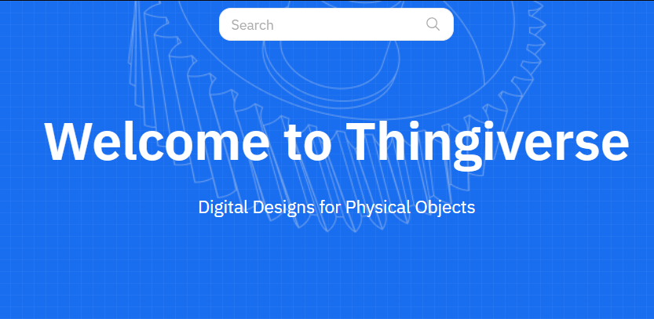Click the Search bar. (Figure 3)

Figure : Indicating the Search Bar on the Thingiverse Homepage.

1. 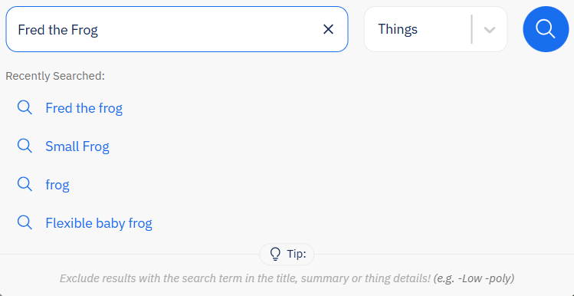Search for keywords relating to what you would like to print. (Figure 4 - A)
   1. Click the magnifying glass icon to search. (Figure 4 – B)

Alternatively, explore Thingiverse for objects that interest you.

Figure : Use keywords or titles to find the perfect model to print.

1. Select a model that matches your criteria. (Figure 5)

Note: The models chosen for printing should be small to avoid extended print times. Keeping the model palm-sized is recommended.

Figure : Example of Thingiverse search results.

1. A screenshot of a computer

   AI-generated content may be incorrect.Click Comments. (Figure 6)

Figure : Reviewing file comments on Thingiverse.

Note: These are user comments. Make sure your chosen model has no reported printing problems. Return to **Step 3** if any user-reported issues are present.

1. 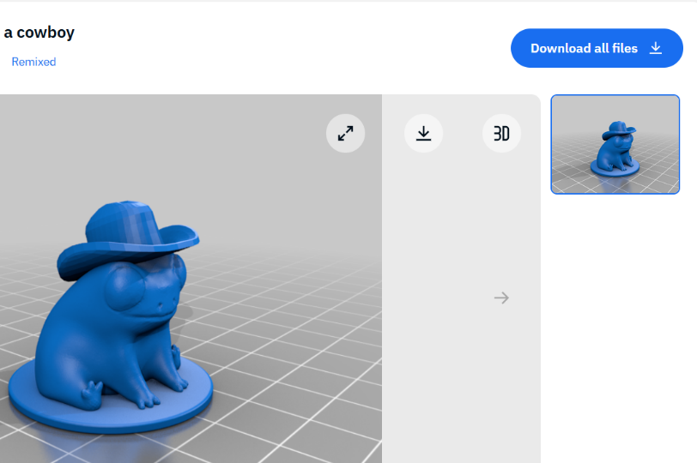Click Download all files.   
   (Figure 7)

Figure : Indicating Download all files button.

1. 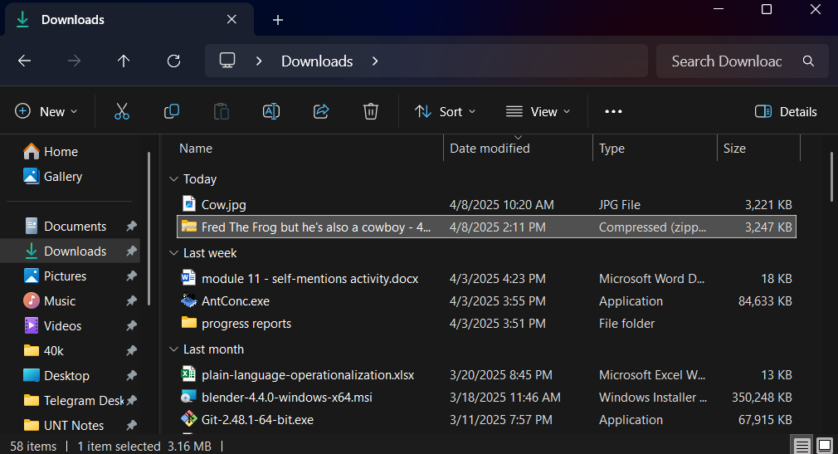Locate the downloaded file(s) in File Explorer. (Figure 8)

Figure : Finding the downloaded file(s) in file explorer.

1. A screenshot of a computer

   AI-generated content may be incorrect.Right click on the file. (Figure 9)
2. Click Extract All. (Figure 9 – A)
   1. An extraction dialog box will appear.

**A**

Figure : Extracting the downloaded file.

1. A screenshot of a computer

   AI-generated content may be incorrect.Click Extract. (Figure 10)
   1. Note the file path of this extracted folder.

Figure : Final extraction dialog box. Note the Directory Path.

The files are now downloaded. Proceed to **Moving Files to a USB**.

### Moving Files to a USB

1. Insert the USB Drive into the computer.
2. A screenshot of a computer

   AI-generated content may be incorrect.Right-Click on the extracted folder.  
   (Figure 11 – A)

**B**

**A**

1. Select Cut. (Figure 11 – B)
2. Left-Click on the USB Drive directory.  
   (Figure 11 – C)
   1. Example Drive is used in this tutorial.

**C**

Figure : Initiate moving the extracted folder.

1. 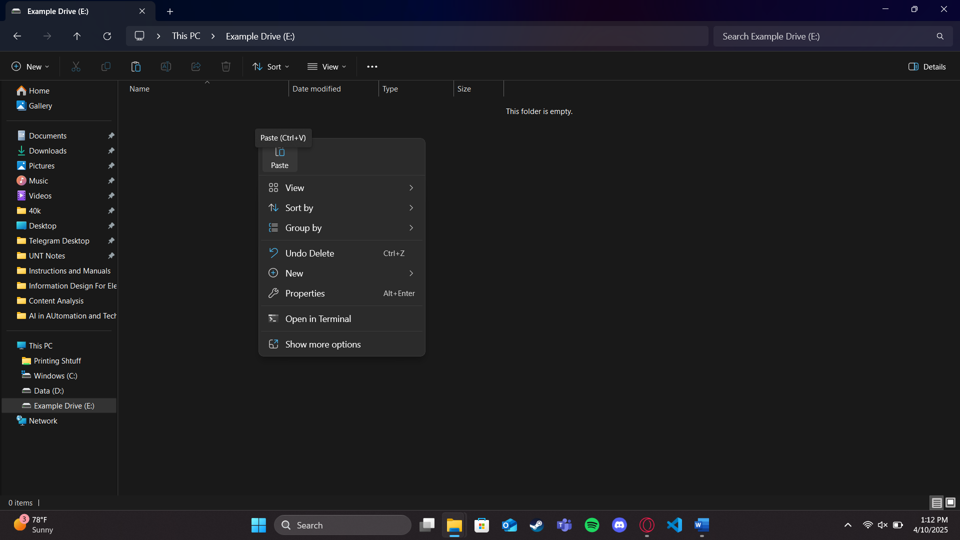Right-Click within the USB drive directory.   
   (Figure 12)

**A**

1. Click Paste.   
   (Figure 12 – A)

Figure : File Explorer within the USB Drive directory.

1. 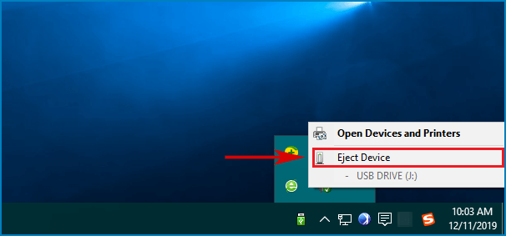Right click on the USB Drive icon on the task bar. (Figure 13 – A)
2. Click Eject Device.   
   (Figure 13 – B)

**B**

1. Remove the USB drive from the computer.

**A**

Figure : Removing the USB Drive device.

The USB drive can now be taken to AUD 301. Proceed to **Slicing the Chosen Model**.

# Slicing the Chosen Model

These instructions are to be completed at the computer within AUD 301. Staff are required to unlock the door to AUD 301, as well as log-in to the computer within. Speak with the TECM Staff within AUD 307 for access. *Slicing* refers to formatting the chosen model file for printing on the PolyPrinter 325dx.

If the chosen model was found outside of AUD 301, insert the USB Drive into the computer before beginning the following steps.

## Instructions

1. 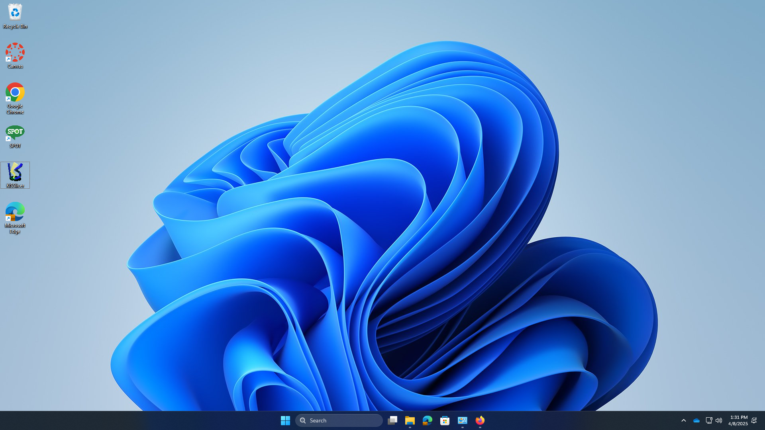Double-Click the KiSSlicer icon on the desktop. (Figure 14)

Figure : The KiSSlicer desktop icon.

1. A computer screen shot of a computer screen

   AI-generated content may be incorrect.Click Open. (Figure 15)
   1. A file explorer box should appear.

Figure : Initial KiSSlicer Screen.

1. A computer screen shot of a computer

   AI-generated content may be incorrect.Navigate to the directory for the downloaded and extracted model. (Figure 16 – A)

**A**

* 1. Reminder: This path will differ if you brought a USB Drive with the file.

**B**

1. Double-Click on the chosen model. (Figure 16 – B)

Figure : Finding the extracted model.

1. A computer screen shot of a frog

   AI-generated content may be incorrect.Exit Mesh Error Key.  
   (Figure 17)

Figure : The mesh error key is not needed for this tutorial.

* 1. This window is for advanced users and is not needed for this tutorial.

1. A computer screen shot of a computer screen

   AI-generated content may be incorrect.Click Slice.  
   (Figure 18)

Figure : The Slice button will format the model for printing.

* 1. The program will take time to slice the model.

1. A computer screen shot of a green cat

   AI-generated content may be incorrect.Click Save.   
   (Figure 19)

Figure : The Save button.

* 1. A file explorer window will appear. Note where the file is being saved.

1. A computer screen shot of a computer screen

   AI-generated content may be incorrect.Name the file.   
   (Figure 20 – A)

Figure : Naming and saving the sliced file.

1. Click Save.   
   (Figure 20 -B)

**A**

**B**

The 3D model has now been sliced and is ready to move on to **Printing the Chosen 3D Model**.

# Printing the Chosen 3D Model

These instructions will guide the user through printing their chosen and sliced 3D model. If the file is not yet sliced, refer to **Slicing the Chosen Model**. The following must be completed at the computer within AUD 301; see **Introduction** for information on permission and access to the room and materials.

Note – The network path for the printer should automatically open with the default search engine. If it does not navigate to 192.168.1.3 on the search engine.

Figure : Navigating to printer control screen.

## Instructions

1. A screenshot of a computer

   AI-generated content may be incorrect.Click Upload G-Code File(s). (Figure 22)

Figure : Upload G-Code File(s) button.

* 1. A dialog box will open to search for the file.

**A**

1. Navigate to the sliced file directory. (Figure 23 – A)

**B**

1. Click on the saved gcode file.   
   (Figure 23 – B)
2. Click Open.   
   (Figure 23 – C)

**C**

Figure : Uploading the G-Code file.

1. A screenshot of a computer

   AI-generated content may be incorrect.Click Close. (Figure 24)

Figure : Upload Complete dialog box.

1. A screenshot of a computer

   AI-generated content may be incorrect.Click each of the three Set buttons. (Figure 25)

Figure : Clicking Set will begin heating the print bed and extruders.

1. A screenshot of a computer

   AI-generated content may be incorrect.Click on the uploaded .gcode file. (Figure 26)
   1. A confirmation dialog box will appear.

Figure 26: Preparing the uploaded file for printing.

1. A screenshot of a computer

   AI-generated content may be incorrect.Click Yes.  
   (Figure 27)

Figure 27: The final confirmation box before printing.

The PolyPrinter should begin the printing process. The heated extruder will deposit plastic material in patterns as commanded by the uploaded gcode. An estimated print time will be displayed, though this may be inaccurate. It is important to remain in AUD 301 as the printer completes your file.

Ensure the cover is closed on the printer (Figure 27). The heat and fumes within can cause issues if left uncovered.

Figure : The PolyPrinter 325dx with a **closed cover**.

# Removing the Print

When the print is completed wait five minutes for the printer to cool down. Handling the print while the printer is heated can cause injury. Proceed when the printer and print reach a manageable temperature.

Removing the print may be as simple as pulling it from the print bed. These instructions will cover a more sure way to remove the print if any trouble is had. Materials are available from the toolbox located near the printer (Figure 28).

Figure : PolyPrinter 325dx and Materials toolbox.

## Materials

|  |  |
| --- | --- |
| Material | Image |
| Removal Tool |  |
| Pliers |  |

## Instructions

1. Open the printer cover.
2. Hold the removal tool against the base of the model.
   1. If this is your first time removing a print, then assistance from a qualified staff member may be needed. Improper handling of the removal tool could damage the print bed.
3. Apply slight pressure from the removal tool to the base of the model while firmly pulling on the model.
   1. The tool should work its way under the model. It will eventually separate the model from the bed.
4. Use the available pliers to remove any lingering supports from the model.
5. Remove any lingering material from the print bed.
6. Close the fume cover.

# Troubleshooting

Find below the answers to common questions about utilizing the 3D printer within AUD 301.

**How do I know if my chosen file is good?**

Reviewing the Comments section on an object’s Thingiverse page is the first step in qualifying a file. If problems are reported frequently, it is likely that the file is unstable or otherwise inadvisable to print.

The size of the chosen print should not exceed the palm of your hand. If you are unsure about the size of an object refer to the comments or description of the file. Alternatively, speak with a qualified staff member in AUD 307.

**I can’t find the downloaded model.**

The default download location is the Downloads folder. If you still can’t find it, locate the Downloads button on your browser and select the option to Show in Folder.

**My model won’t print.**

When following the **Printing the Chosen 3D Model** instructions the selected file must be a .gcode file extension. This file type is required to utilize the 3D printer.

**My print failed.**

Several issues can cause this, see below for common problems:

**Heat Issues**

The PolyPrinter webpage screen will display a heating error. The printer will stop itself. Speak with qualified staff to resolve this problem.

**Print Supports**

Incorrect support can lead to a failed print. In cases like these, the print lacks support or is improperly supported. Failures look like random tangles of filament left on or above the print bed. To correct, reload the original .stl file in KiSSlicer and follow the slicing instructions again. If the print continues to fail, then the support settings will need to be reviewed by qualified TECM Staff.

**Print Bed Adhesion**

Poor adhesion can cause the print to slip while printing, leaving the filament to tangle on or around the print. The difference in this failure is the original print being moved or tipped over on the print bed when partially completed. To correct, notify a qualified staff member.

**Lack of Filament**

A lack of filament will leave a model unfinished with no visible filament tangling or print shifting. To correct, notify a qualified staff member. Please watch for this error, as an extruder with no filament can be damaged by the heating element.

**My print isn’t the right color.**

Limited colors of filament are available. Please speak with a qualified staff member before beginning your print to see if the desired color is available. If it is not available, standard spray primer and acrylics work well to paint printed models.